7 Wall Collision

The Controller Object
In order to have our little character crash into a wall and actually have that wall push back, or prevent the little guy from going through it, we are going to have to create this this controller object. The controller object is a very important element in the game, even though it is more of a ghost, which means for the most part, it is invisible.

Main purposes
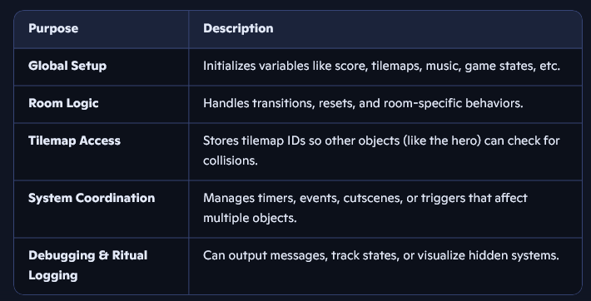
Without a controller the tilemap ID is not stored, and we need to store it so that our hero can check for collision with the wall, and other things. When you have a controller, it controls things, and when it says “Thou shall not go through them thar walls” well, you are not going to be going through any walls.

Create the Controller
if you are in the room tab, you want to go back to the Workspace 1 tab, to find the Asset Browser again.
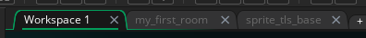
Now go to Objects in the Asset Browser.
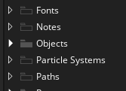
Right click on the object’s folder and then go to Create -Object
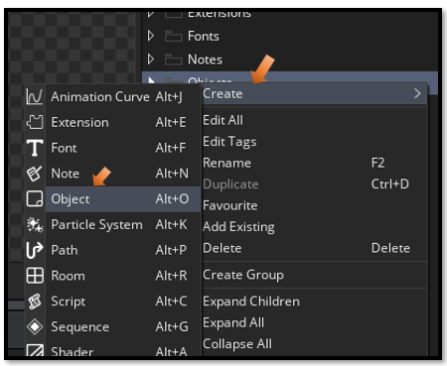
You can name it obj_controller, it will be invisible in the room, so no sprite is needed for it.
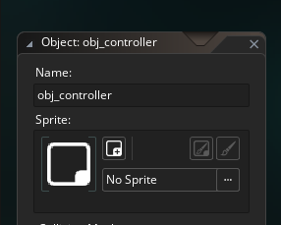

Controller Create Event
Click on the obj_controller in the Asset Browser to come into its code. Add a Create event, and put this code into the controllers create event.
global.tilemap_wall = layer_tilemap_get_id("Wall_Tiles");

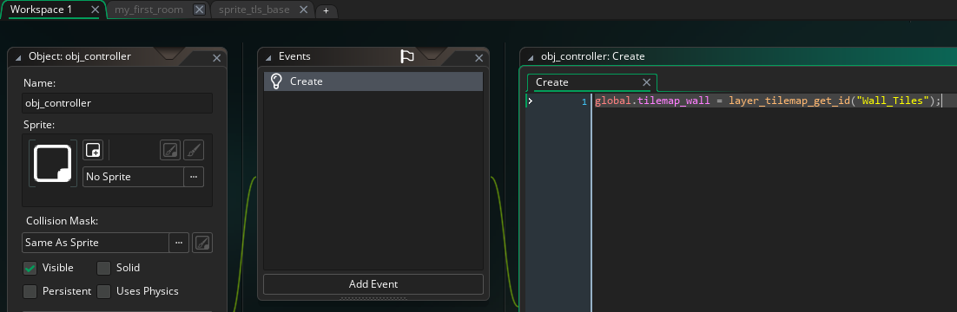

The object_hero step event
Now double click on the object_hero
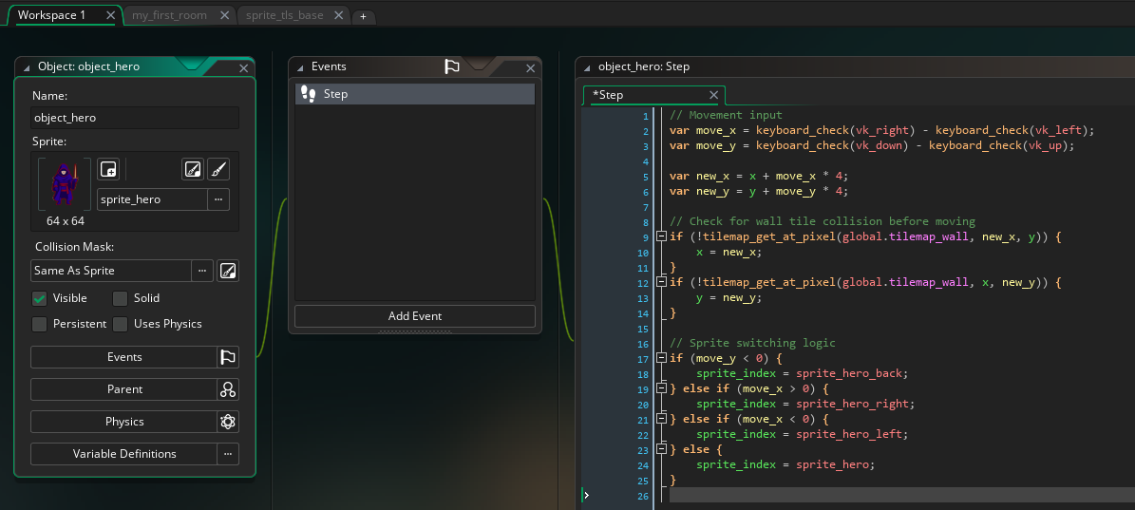

var move_x = keyboard_check(vk_right) - keyboard_check(vk_left);
var move_y = keyboard_check(vk_down) - keyboard_check(vk_up);

var new_x = x + move_x * 4;
var new_y = y + move_y * 4;

// Check for wall tile collision before moving
if (!tilemap_get_at_pixel(global.tilemap_wall, new_x, y)) {
x = new_x;
}
if (!tilemap_get_at_pixel(global.tilemap_wall, x, new_y)) {
y = new_y;
}

// Sprite switching logic
if (move_y < 0) {
sprite_index = sprite_hero_back;
} else if (move_x > 0) {
sprite_index = sprite_hero_right;
} else if (move_x < 0) {
sprite_index = sprite_hero_left;
} else {
sprite_index = sprite_hero;
}

